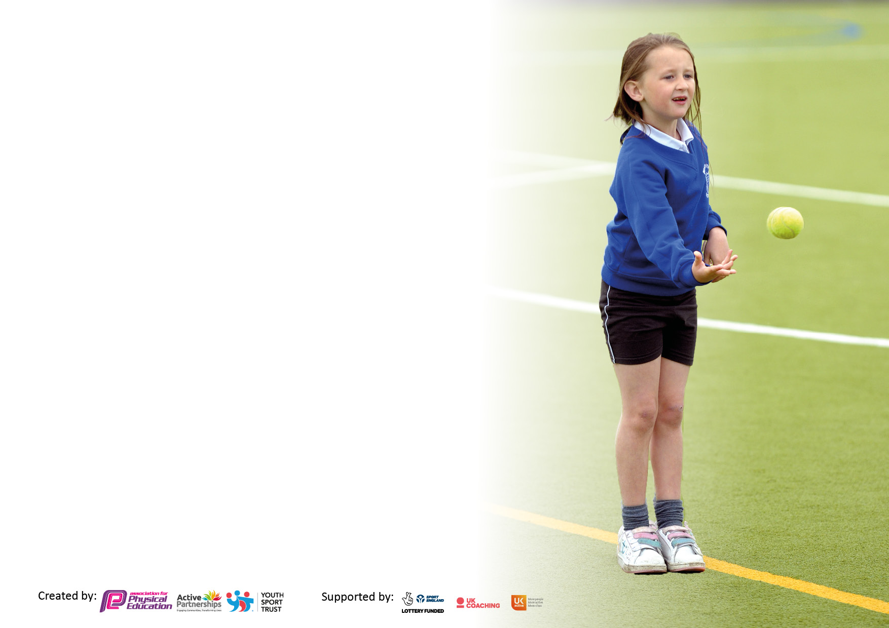

It is important that your grant is used effectively and based on school need. The Education Inspection Framework makes clear there will be a focus on **‘whether leaders and those responsible for governors all understand their respective roles and perform these in a way that enhances the effectiveness of the school’**.

Under the Quality of Education Ofsted inspectors consider:

**Intent** - Curriculum design, coverage and appropriateness

**Implementation** - Curriculum delivery, Teaching (pedagogy) and Assessment

**Impact** - Attainment and progress

To assist schools with common transferable language this template has been developed to utilise the same three headings which should make your plans easily transferable between working documents.

Schools must use the funding to make **additional and sustainable** improvements to the quality of Physical Education, School Sport and Physical Activity (PESSPA) they offer. This means that you should use the Primary PE and sport premium to:

* Develop or add to the PESSPA activities that your school already offer
* Build capacity and capability within the school to ensure that improvements made now will benefit pupils joining the school in future years
* The Primary PE and sport premium should not be used to fund capital spend projects; the school’s budget should fund these.

Pleasevisitgov.ukfortherevisedDfEguidanceincludingthe5keyindicatorsacrosswhichschoolsshoulddemonstrate animprovement.Thisdocumentwillhelpyoutoreviewyourprovisionandtoreportyourspend.DfEencouragesschools to use this template as an effective way of meeting the reporting requirements of the Primary PE and Sport Premium.

We recommend you start by reflecting on the impact of current provision and reviewing the previous spend.

Schools are required to publish details of how they spend this funding, including any under-spend from 2021/2022, as well as on the impact it has on pupils’ PE and sport participation and attainment. **All funding must be spent by 31st July 2023.**

We recommend regularly updating the table and publishing it on your website throughout the year. This evidences your ongoing self-evaluation of how you are using the funding to secure maximum, sustainable impact. Final copy must be posted on your website by the end of the academic year and no later than the 31st July 2023. To see an example of how to complete the table please click HERE.

Created by: Supported by:

**Details with regard to funding**

Please complete the table below.

|  |  |
| --- | --- |
| Total amount carried over from 2022/23 | £6122 |
| Total amount allocated for 2023/24 | £17380 |
| How much (if any) do you intend to carry over from this total fund into 2022/23? | £0 |
| Total amount allocated for 2023/24 | £23502 |
| Total amount of funding for 2023/24. To be spent and reported on by 31st July 2024. | £ 23502 |

**Swimming Data**

Please report on your Swimming Data below.

|  |  |
| --- | --- |
| Meeting national curriculum requirements for swimming and water safety.  N.B. Complete this section to your best ability. For example you might have practised safe self-rescue techniques on dry land which you can then transfer to the pool when school swimming restarts.  **Due to exceptional circumstances priority should be given to ensuring that pupils can perform safe self rescue even if they do not fully meet the first two requirements of the NC programme of study** | N/A – As we are an Infant & Nursery school |
| What percentage of your current Year 6 cohort swim competently, confidently and proficiently over a distance of at least 25 metres?  **N.B.** Even though your pupils may swim in another year please report on their attainment on leaving primary school at the end of the summer term 2022.  Please see note above | N/A – As we are an Infant & Nursery school |
| What percentage of your current Year 6 cohort use a range of strokes effectively [for example, front crawl, backstroke and breaststroke]?  Please see note above | N/A – As we are an Infant & Nursery school |
| **What percentage of your current Year 6 cohort perform safe self-rescue in different water-based situations?** | N/A – As we are an Infant & Nursery school |
| Schools can choose to use the Primary PE and sport premium to provide additional provision for swimming but this must be for activity **over and above** the national curriculum requirements. Have you used it in this way? | N/A – As we are an Infant & Nursery school |

**Action Plan and Budget Tracking**

Capture your intended annual spend against the 5 key indicators. Clarify the success criteria and evidence of impact that you intend to measure to evaluate for pupils today and for the future.

|  |  |  |  |  |
| --- | --- | --- | --- | --- |
| **Academic Year:** 2023/24 | **Total fund allocated: £23502** | **Date Updated: July 2024** | |  |
| **Key indicator 1:** The engagement of all pupils in regular physical activity – Chief Medical Officers guidelines recommend that primary school pupils undertake at least 30 minutes of physical activity a day in school | | | | Percentage of total allocation: |
| % |
| **Intent** | **Implementation** | | **Impact** |  |
| Your school focus should be clear what you want the pupils to know and be able to do and about  what they need to learn and to  consolidate through practice: | Make sure your actions to achieve are linked to your intentions: | Funding allocated: | Evidence of impact: what do pupils now know and what can they now do? What has changed?: | Sustainability and suggested next steps: |
| Improve the health of children in school by encouraging regular exercise alongside the other important aspects of a healthy lifestyle.  To ensure ‘active’ playtimes so that all children are participating in additional physical activity every week.  To encourage the use of scooters to travel to school to provide up to 30 minutes of activity to and from school. | * Coach employed to lead active playtimes etc. * Vision to be shared with whole school staff of what we are trying to promote, links to health message, water/fruit in classrooms, lunchtime choices. * Termly health message, launched in assembly, used in PE/dinner/break times, shared with parents and homework sent home to link. * Look at CLICK long term planning with Science coordinator to ensure balanced teaching on health included in curriculum. * PE subject leader to ensure that resources are regularly updated and replaced when necessary. | Project Sport £285 per week for an additional coach working 2 days 1-3pm and 1 day 1pm-4pm  £13380  Playground equipment £2859 | * Timetables to show number of children participating in active playtimes. * All KS1 pupils to be involved in high quality activity weekly. WIDER IMPACT AS A RESULT OF ABOVE ⎫ Pupils are more active in PE lessons, e.g. take part without stopping to rest. ⎫ Standards achieved in PE NC are improving, see school data for % achieving end of KS target. ⎫ Attitudes to learning improved, better concentration in lessons. ⎫ SAT results improved, see data. * Fitness test results completed by sports coach show an improvement in levels across the year. | * SLT to embed this message into the ethos of the school through regular planning, practice and evaluation. * Resources bought to be maintained and replaced as needed to ensure children have access to quality equipment. |
| **Key indicator 2:** The profile of PESSPA being raised across the school as a tool for whole school improvement | | | | Percentage of total allocation: |
| % |
| **Intent** | **Implementation** | | **Impact** |  |
| Your school focus should be clear what you want the pupils to know and be able to do and about  what they need to learn and to  consolidate through practice: | Make sure your actions to achieve are linked to your intentions: | Funding allocated: | Evidence of impact: what do pupils now know and what can they now do? What has changed?: | Sustainability and suggested next steps: |
| A sports star from each key stage is chosen weekly and shared through social media (class dojo) so that all parents are aware of the importance of PE and sport.  Display boards around school changed regularly to promote children’s achievements. | * Additional sporting achievements to be shared in the weekly celebration assemblies. * Include results of any competitions, medal giving etc as part of celebration assembly. * Leaflets sent home from Huddersfield Town/Giants to promote local sporting events. * Termly health message letter and homework sent home so that parents are aware of what is being taught. * Coordinator quality assurance timetable in place to check on displays. * Big sporting events are promoted in school so that pupils are aware that they are on. | medals, certificates and stickers | * Parents will have attended assemblies or seen on schools social media. (parent comment book will be available afterwards) * Class Dojo/letters to parents contains lots of information about clubs/competitions/results and children are keen to be involved. WIDER IMPACT AS A RESULT OF ABOVE ⎫ Pupils are very proud to be involved in assemblies/photos on notice boards etc which impacts on confidence and self-esteem. ⎫ Overall increased self-esteem/confidence having an impact on learning across the curriculum. | * The SLT has seen the benefits of the raised profile and is committed to funding these areas if the funding is discontinued. * PE subject leader to maintain social media and communication with parents about sporting events, clubs etc. |

|  |  |  |  |  |
| --- | --- | --- | --- | --- |
| **Key indicator 3:** Increased confidence, knowledge and skills of all staff in teaching PE and sport | | | | Percentage of total allocation: |
| % |
| **Intent** | **Implementation** | | **Impact** |  |
| Your school focus should be clear | Make sure your actions to | Funding | Evidence of impact: what do | Sustainability and suggested |
| what you want the pupils to know | achieve are linked to your | allocated: | pupils now know and what | next steps: |
| and be able to do and about | intentions: |  | can they now do? What has |  |
| what they need to learn and to |  |  | changed?: |  |
| consolidate through practice: |  |  |  |  |
| In order to improve progress and achievement of all pupils the focus is on upskilling the staff by providing coaches to work alongside staff for the teaching of dance this year. | * Whole staff professional learning to include teachers, teaching assistants.   • PE subject leader to provide  updates throughout the year in  staff meetings.   * PE subject leader to meet with a broad range of pupils to talk about their PE lessons and to ascertain their knowledge and understanding of the subject. * Pupil voice questionnaires completed as part of the QA cycle. * PE subject leader and Key Stage One teachers to discuss positive outcomes and what areas there are for development. * Professional development in subject leadership for PE subject leader. * PE lead to ensure all staff have appropriate kit for teaching and supporting PE. | See indicator 1 for the cost of coach  £585 Scootfit | * The focus of lessons are now child centered and as a result pupils are engaged and are keen to learn and improve. * As a result, pupils made good or better progress both in lessons and over time (see teachers' planning and records). * End of KS1 results, how many expected, emerging, exceeding at PE (to track year on year) * Almost all pupils, when questioned, said that PE lessons were really challenging and exciting and that they really enjoyed PE. (See pupil questionnaires) WIDER IMPACT AS A RESULT OF ABOVE ⎫ Skills, knowledge and understanding of pupils are significantly increased. ⎫ Pupils really enjoy PE and sport, are very keen to take part and demonstrate a real desire to learn and improve. * Evidence of pupils work in PE in CLICK books. | * PE subject Leader to support new staff in school with planning for delivery of physical education. * Arrange team teaching opportunities and supportive lesson observations in order to develop the quality of teaching, learning and assessment. * PE subject Leader to identify any staff who need further support and to provide appropriate professional learning. * Further professional learning opportunities for staff who request it. For example: Teachers to buddy up and carry out peer observations to support continual learning. * PE Subject Leader to monitor and to provide support as appropriate in order to ensure progress and achievement are maintained by all pupils. * PE Subject leader networks with colleagues at other schools to encourage ongoing sharing of good practice across schools |
| **Key indicator 4:** Broader experience of a range of sports and activities offered to all pupils | | | | Percentage of total allocation: |
| % |
| **Intent** | **Implementation** | | **Impact** |  |
| Your school focus should be clear | Make sure your actions to | Funding | Evidence of impact: what do | Sustainability and suggested |
| what you want the pupils to know | achieve are linked to your | allocated: | pupils now know and what | next steps: |
| and be able to do and about | intentions: |  | can they now do? What has |  |
| what they need to learn and to |  |  | changed?: |  |
| consolidate through practice: |  |  |  |  |
| A wide variety of regular afterschool clubs to be offered to all KS1 children to ensure children help foster a lifelong enjoyment of sport and PE. To target disadvantaged pupils, those with talents, EAL and SEN children. | * Curricular and extra-curricular plan for the year making sure a broad range of activities on offer. * Discussions with individual pupils and liaison with parents / careers * Employing a specialist teacher to lead and model lessons. * Purchasing specialist equipment and teaching resources to develop a non-traditional activity as needed. * Promote the clubs on offer in school, e.g. assemblies. | £0 Clubs run by coaches as part of the package.  £1154 Afterschool club salary  £352 PE Kit | * Registers of participation * Photographic record * Feedback from the pupils on the clubs to feed into which are provided. * Pupils are keen to participate and clubs are always full. * Improved standards * Positive attitudes to health and wellbeing * Track achievement in PE of those who attend clubs. WIDER IMPACT AS A RESULT OF ABOVE ⎫ Pupils will be enthused to sign up for clubs throughout their time at our campus ensuring they are involved in regular activity. | • PE coordinator to make sure clubs are run effectively and spend time in them to ensure quality.  • PE coordinator to make sure children’s feedback on clubs is a key factor in determining which clubs run. |

|  |  |  |  |  |
| --- | --- | --- | --- | --- |
| **Key indicator 5:** Increased participation in competitive sport | | | | Percentage of total allocation: |
| % |
| **Intent** | **Implementation** | | **Impact** |  |
| Your school focus should be clear | Make sure your actions to | Funding | Evidence of impact: what do | Sustainability and suggested |
| what you want the pupils to know | achieve are linked to your | allocated: | pupils now know and what | next steps: |
| and be able to do and about | intentions: |  | can they now do? What has |  |
| what they need to learn and to |  |  | changed?: |  |
| consolidate through practice: |  |  |  |  |
| As a school we believe that getting girls into football will have the following impact:   * Bring players together as a team, teaching teamwork and leadership skills. * Help girls build self-confidence and provide an outlet for body stigma. * Prepare girls for future social and professional interactions. * Provide a better environment for girls. * Improve physical health.   *Research carried out by Childwise, which asks the opinions of children, found that less than half of girls (47%) believe they have had equal opportunities to play football, compared to two thirds (68%) of boys at the same age.*  **The Football Association has promised to give every girl in England equal access to football in PE lessons by 2024 it is our aim at Netherhall St James to support this.** | * School to purchase all necessary resources, nets and footballs * Support from resident PE coach and their company to support delivery. * Head teacher to lead a girl’s football session during lunchtime play once a week over a half term. * School to provide certificates when pupils work hard. * PE Coach to start with a girls football club in the Autumn term and then continue to provide opportunities throughout the year. * PE coordinator to promote girls football and profile some players as part of whole school assemblies.   PE coordinator to get in touch with local clubs to see what they are offering to girls and then promote in school. |  | * Improved positive attitudes to health and well-being and PESS * Timetabled sessions to show all pupils have opportunity to participate. * Pupils will have fun whilst playing and learning the sport (evident from pupil voice) * WIDER IMPACT AS A RESULT OF ABOVE ⎫ Improved standards in PE within curriculum time. ⎫ A wide variety of children, including disadvantaged groups are keen to take part. * Pupils will develop their agility, balance, coordination, muscle strength and endurance this is transferable to other sporting activities/PE lessons which will help them to develop a healthy active lifestyle as they grow up. * Pupils will develop a love of the game that will continue throughout their lifetime. | * With the investment of the football equipment this year SLT will ensure that it becomes part of our curriculum going forward. |

|  |  |
| --- | --- |
| Signed off by | |
| Head Teacher: | Kirsty McGrath |
| Date: | 20.09.2024 |
| Subject Leader: | Louise Berry |
| Date: | 20.09.2024 |
| Governor: | Geoff Kernan |