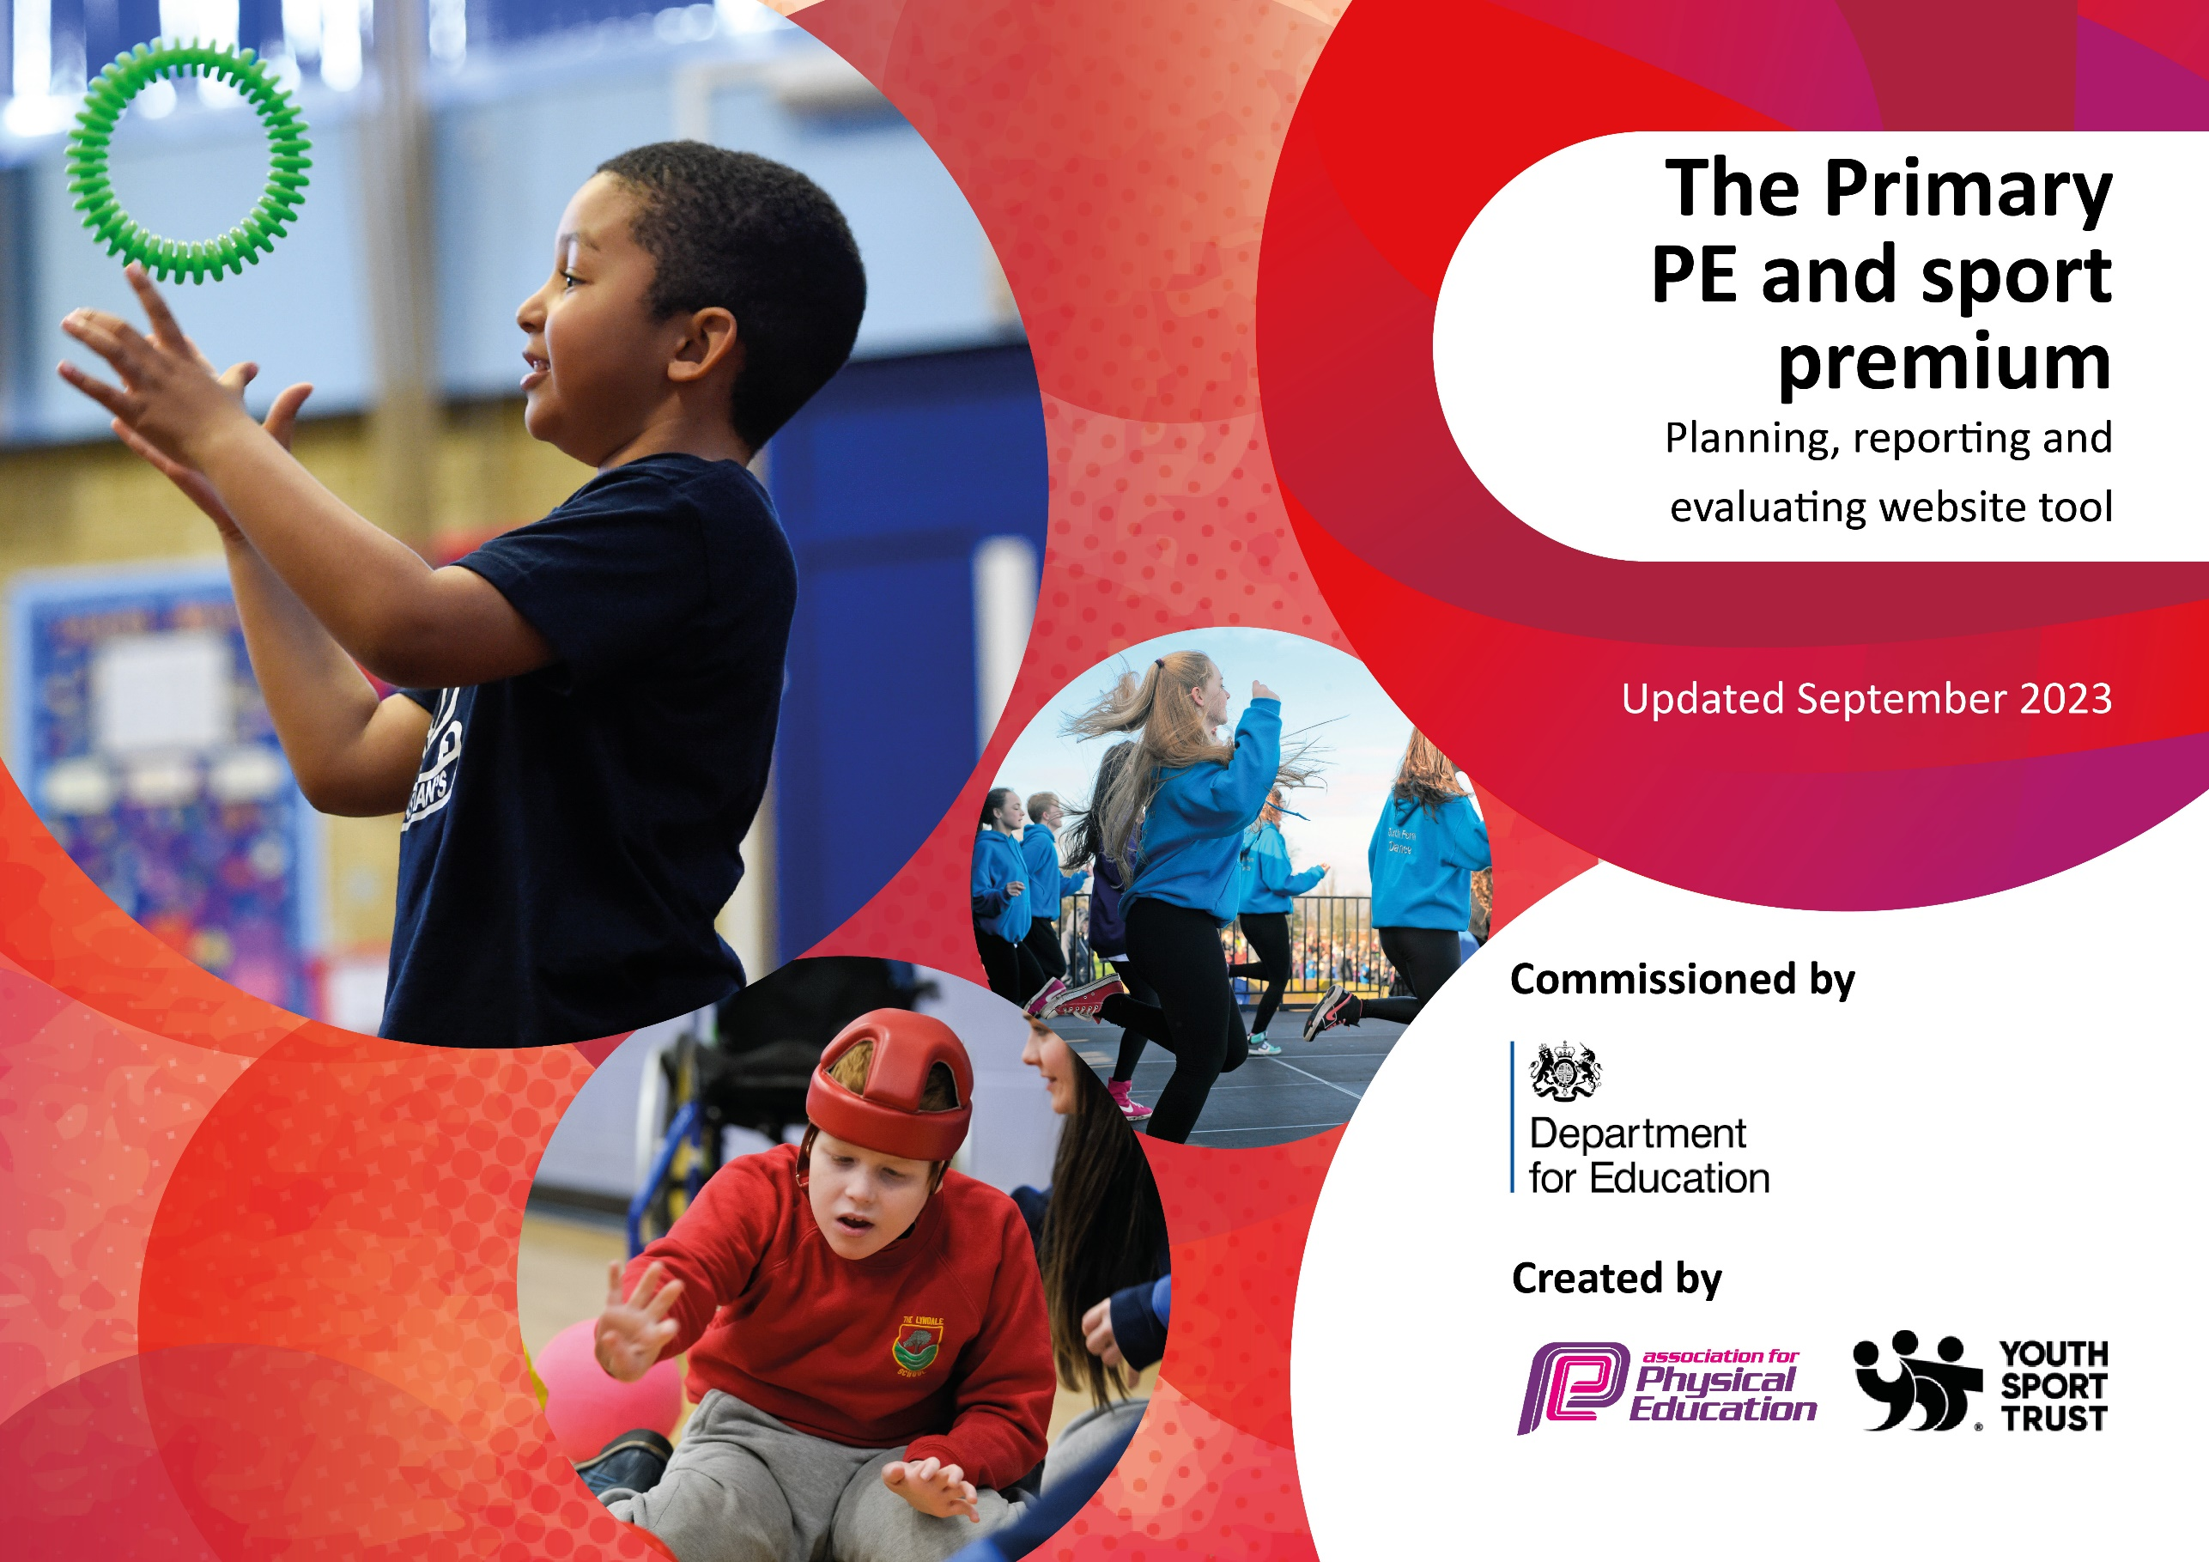

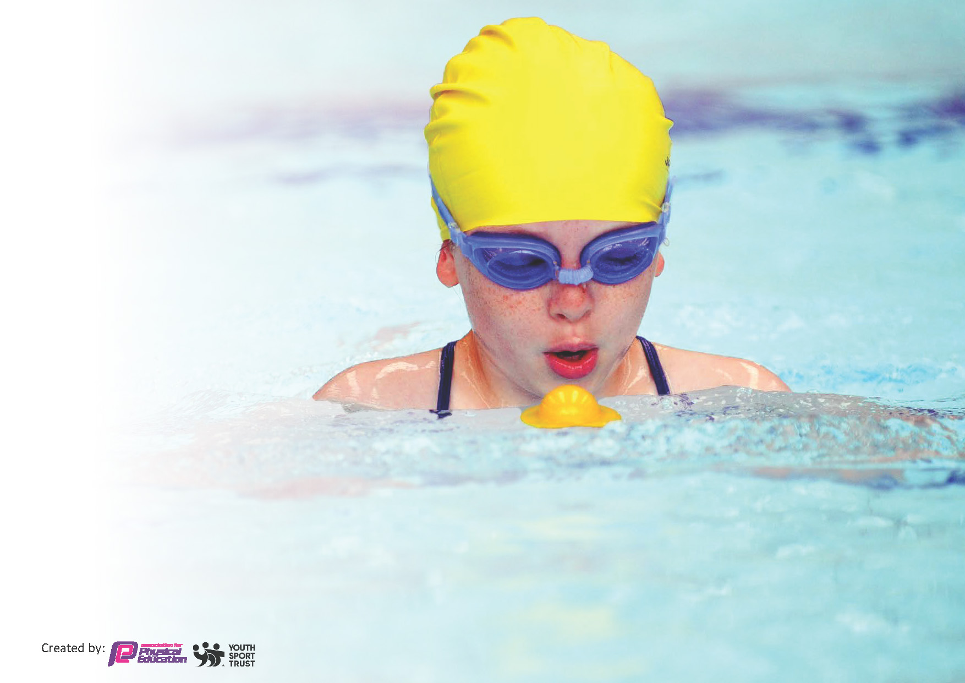
This template can be used for multiple purposes:
by:
- It enables schools to effectively plan their use of the Primary PE and sport premium
- It helps schools to meet the requirements (as set out in guidance) to publish information on their Primary PE and sport premium
- It will be an effective document to support Ofsted inspections enabling schools to evidence progress in Physical Education (PE) and evidence swimming attainment, which forms part of the PE National Curriculum. We would recommend schools consider
the Intent, Implementation and Impact of any spend, as examined within the Education Inspection Framework.

It is important that your grant is used effectively and based on school need.

Schools must use the funding to make additional and sustainable
improvements to the quality of the PE, School Sport and Physical Activity (PESSPA)
they offer. This means that you should use the Primary PE and sport premium to:

- Build capacity and capability within the school to ensure that improvements made now will benefit pupils joining the school in future years
- Develop or add to the PESSPA activities that your school already offers.

The Primary PE and sport premium should not be used to fund capital spend projects; the school’s core budget should fund these. Further detail on capital expenditure can be found in the updated Primary PE and sport premium guidance.

The Primary PE and sport premium guidance, outlines 5 key priorities that funding should be used towards. It is not

necessary that spending has to meet all the key priorities, you should select the priorities that you aim to use any funding towards.

Although completing this template is not a requirement for schools, schools are required to publish details of how they spend this funding. Schools must also outline what the impact this funding has had on pupils’ PE and sport participation and attainment and how any spending will be sustainable in the future. All funding must be spent by 31st July 2024.

The Department for Education has worked closely with the Association for Physical Education (afPE) and the Youth Sport Trust (YST) to develop this template and encourages schools to use it. This template is an effective way of meeting the reporting requirements of the Primary PE and sport premium.
Review of last year’s spend and key achievements (2023/2024)

We recommend you start by reflecting on the impact of current provision and reviewing your previous spend.

Activity/Action | Impact | Comments
Key indicator 1: The engagement of all pupils in regular physical activity – Chief Medical Officers guidelines recommend that primary school pupils undertake at least 30 minutes of physical activity a day in school  Improve the health of children in school by encouraging regular exercise alongside the other important aspects of a healthy lifestyle.  To ensure ‘active’ playtimes so that all children are participating in additional physical activity every week.  To encourage the use of scooters to travel to school to provide up to 30 minutes of activity to and from school.  Key indicator 2: The profile of PESSPA being raised across the school as a tool for whole school improvement  A sports star from each key stage is chosen weekly and shared through social media (class dojo) so that all parents are aware of the importance of PE and sport.  Display boards around school changed regularly to promote children’s achievements.  Key indicator 3: Increased confidence, knowledge and skills of all staff in teaching PE and sport  In order to improve progress and achievement of all pupils the focus is on upskilling the staff by providing coaches to work alongside staff for the teaching of dance this year.  Key indicator 4: Broader experience of a range of sports and activities offered to all pupils  A wide variety of regular afterschool clubs to be offered to all KS1 children to ensure children help foster a lifelong enjoyment of sport and PE. To target disadvantaged pupils, those with talents, EAL and SEN children.  Key indicator 5: Increased participation in competitive sport  As a school we believe that getting girls into football will have the following impact:  - Bring players together as a team, teaching teamwork and leadership skills.  - Help girls build self-confidence and provide an outlet for body stigma.  - Prepare girls for future social and professional interactions.  - Provide a better environment for girls.  - Improve physical health.  Research carried out by Childwise, which asks the opinions of children, found that less than half of girls (47%) believe they have had equal opportunities to play football, compared to two thirds (68%) of boys at the same age.  The Football Association has promised to give every girl in England equal access to football in PE lessons by 2024 it is our aim at Netherhall St James to support this. | - Timetables to show number of children participating in active playtimes.  - All KS1 pupils to be involved in high quality activity weekly. WIDER IMPACT AS A RESULT OF ABOVE ⎫ Pupils are more active in PE lessons, e.g. take part without stopping to rest. ⎫ Standards achieved in PE NC are improving, see school data for % achieving end of KS target. ⎫ Attitudes to learning improved, better concentration in lessons. ⎫  - Parents will have attended assemblies or seen on schools social media. (parent comment book will be available afterwards)  - Class Dojo/letters to parents contains lots of information about clubs/competitions/results and children are keen to be involved. WIDER IMPACT AS A RESULT OF ABOVE ⎫ Pupils are very proud to be involved in assemblies/photos on notice boards etc which impacts on confidence and self-esteem. ⎫ Overall increased self-esteem/confidence having an impact on learning across the curriculum.  - The focus of lessons are now child centered and as a result pupils are engaged and are keen to learn and improve.  - As a result, pupils made good or better progress both in lessons and over time (see teachers' planning and records).  - End of KS1 results, how many expected, emerging, exceeding at PE (to track year on year)  - Almost all pupils, when questioned, said that PE lessons were really challenging and exciting and that they really enjoyed PE. (See pupil questionnaires) WIDER IMPACT AS A RESULT OF ABOVE ⎫ Skills, knowledge and understanding of pupils are significantly increased. ⎫ Pupils really enjoy PE and sport, are very keen to take part and demonstrate a real desire to learn and improve.  - Evidence of pupils work in PE in CLICK books.  - Registers of participation  - Photographic record  - Feedback from the pupils on the clubs to feed into which are provided.  - Pupils are keen to participate and clubs are always full.  - Improved standards  - Positive attitudes to health and wellbeing  - Track achievement in PE of those who attend clubs. WIDER IMPACT AS A RESULT OF ABOVE ⎫ Pupils will be enthused to sign up for clubs throughout their time at our campus ensuring they are involved in regular activity.  - Improved positive attitudes to health and well-being and PESS  - Timetabled sessions to show all pupils have opportunity to participate.  - Pupils will have fun whilst playing and learning the sport (evident from pupil voice)  - WIDER IMPACT AS A RESULT OF ABOVE ⎫ Improved standards in PE within curriculum time. ⎫ A wide variety of children, including disadvantaged groups are keen to take part.  - Pupils will develop their agility, balance, coordination, muscle strength and endurance this is transferable to other sporting activities/PE lessons which will help them to develop a healthy active lifestyle as they grow up.  - Pupils will develop a love of the game that will continue throughout their lifetime. | Investment in playtimes and equipment has meant that there are lots of opportunities for children to be active. Scooters are now a regular feature of break times and lunchtimes. Next year we need to look at facilitating scooter storage so that pupils can ride scooters to school. We also need to look at a class rota system to make sure all pupils access an adult led activity at lunchtimes once a week.  This is successfully embedded now into school life and sporting achievements inside and outside of school are celebrated. Class Dojo has had a great impact on sharing achievements and what happens in PE lessons with parents. We currently have a PE board but we are going to update this into a combined health and PE board to relaunch this as part of our next plan.  Pupils at our school consistently do well in PE with 80% or over achieving expected each year for the last 3 years. Pupil voice is always very positive and it often comes back as a favourite subject in school. Staff have benefitted from having excellent PE lessons modelled by coaches and they work directly with them to teach sessions to ensure their confidence. We have changed coach for this upcoming year to offer a refreshed approach and to support us develop a new assessment system for PE.  We continue to offer a really good range of clubs which are always full. These are equal opportunities for all and extra adult support is provided to remove any barriers to participation for SEN pupils.  We had a big push on football and as a result developed a regular football team who attended training sessions after school which they really enjoyed. Whilst the afterschool team did not attract as many girls as we had hoped, lots had the opportunity to play at lunchtimes and during PE lessons.

Key priorities and Planning
This planning template will allow schools to accurately plan their spending.

Action – what are you planning to do | Who does this action impact? | Key indicator to meet | Impacts and how sustainability will be achieved? | Cost linked to the action
To improve the health of children in school by encouraging regular exercise alongside the other important aspects of a healthy lifestyle.  We will ensure ‘active’ playtimes so that all children are participating in additional physical activity every week; a rota will be in place so that the coach or lunchtime staff/teacher can hold a session for each class.  We will encourage the use of scooters to travel to school to provide up to 30 minutes of activity to and from school.  To improve progress and achievement of all pupils  We will focus on upskilling the staff by providing coaches to work alongside staff to use a new assessment tool that tracks pupil progress and allows teachers to identify and target pupils needs. | Active playtimes  Lunchtime supervisors / teaching staff, coaches - as they need to lead the activity and be aware of timetable/rota  Pupils – as they will take part.  Scooting to and from school  School leadership who will oversee logistics.  Pupils – who choose to take part.  Parents – as they will be involved if they want their child to take part in this new initiative.  Curriculum lead and PE Coordinator who will oversee implementation of new assessment tool.  Coach who will provide support  Teachers who will work with the coach to implement new assessment  Pupils who will take part on sessions | Key indicator 2: The engagement of all pupils in regular physical activity – Chief Medical Officers guidelines recommend that primary school pupils undertake at least 30 minutes of physical activity a day in school  Key indicator 3: Increased confidence, knowledge and skills of all staff in teaching PE and sport | Active playtimes  - All KS1 pupils to be involved in high quality activity weekly.  Scooting to and from school  - More pupils using an active way to get to and from school will increase fitness levels.  WIDER IMPACT & SUSTAINABILITY AS A RESULT OF ABOVE  These initiatives will be sustained by becoming a regular part of school practice.  Pupils are more active in PE lessons, e.g. take part without stopping to rest. Standards achieved in PE NC are improving, see school data for % achieving end of KS target.  Attitudes to learning improved, better concentration in lessons.  Good habits of leading an active lifestyle will be formed from an early age.  - The focus of lessons will tailored to the knowledge and skills the pupils need to learn as a result pupils will improve.  - As a result, pupils made good or better progress both in lessons and over time (see teachers' planning and records).  - End of KS1 results, how many expected, emerging, exceeding at PE (to track year on year)  - Pupil voice shows impact of how pupils view their lessons and any feedback they give is fed back and taken on board for future sessions. (See pupil questionnaires)  WIDER IMPACT & SUSTAINABILITY AS A RESULT OF ABOVE  Skills, knowledge and understanding of pupils are significantly increased. Pupils really enjoy PE and sport, are very keen to take part and demonstrate a real desire to learn and improve.  Teachers will take what they learn from working with the coach to then apply each year to lead high quality PE. | £7644 for additional coaches to support lunchtime sessions.  £8840 Yearly replenish of playground equipment to maintain high quality resources  £3.99 x 40 (£159.60)  Cost of scooter padlocks/chains which parents will use to lock up scooters.  Burg-Wächter , Bicycle lock 260 60, Standard (assorted colors) : Amazon.co.uk: Sports & Outdoors  See above cost of coach

To increase participation in competitive sport  We will ensure that we offer a wide variety of clubs which will give pupils a pathway to going onto to do competitive sport.  We will have a particular focus on getting girls into sports like football.  We will run in-house competitions throughout the year to provide pupils with the opportunity to celebrate their skills, to learn how to be good sportspeople and see competition as not being about winning but being the celebration of enjoying sport. | Curriculum lead and PE Coordinator who will oversee the running of competitions/clubs and make sure they are open to all.  Coach/teachers who will run competitions/clubs  Pupils who will take part in competitions/clubs. | Key indicator 5: Increased participation in competitive sport | As a school we believe that getting girls and all pupils into team sports will have the following impact:  - Bring players together as a team, teaching teamwork and leadership skills.  - Help pupils build self-confidence and provide an outlet for body stigma.  - Prepare pupils for future social and professional interactions.  - Provide a better environment for equal opportunities.  - Improve physical health.  - Timetabled sessions to show all pupils have opportunity to participate.  - Pupils will have fun whilst playing and learning the sport (evident from pupil voice)  WIDER IMPACT AS A RESULT OF ABOVE ⎫ Improved standards in PE within curriculum time. A wide variety of children, including disadvantaged groups are keen to take part.  Pupils will develop their agility, balance, coordination, muscle strength and endurance this is transferable to other sporting activities/PE lessons which will help them to develop a healthy active lifestyle as they grow up.  Pupils will develop a love of a team sport that will continue throughout their lifetime. | £2184 Cost of the coach to run clubs  £4000 cost to run additional clubs internally

Key achievements 2024-2025
This template will be completed at the end of the academic year and will showcase the key achievements schools have made with their Primary PE and sport premium spending.

Activity/Action | Impact | Comments

Swimming Data – Not applicable as an Infant & Nursery School
Meeting National Curriculum requirements for swimming and water safety.
Priority should always be given to ensuring that pupils can perform safe self-rescue even if they do not fully meet the first two requirements of the National Curriculum programme of study

Question | Stats: | Further context  Relative to local challenges
What percentage of your current Year 6 cohort can swim competently, confidently and proficiently over a distance of at least 25 metres? | %
What percentage of your current Year 6 cohort can use a range of strokes effectively [for example, front crawl, backstroke, and breaststroke]? | %

What percentage of your current Year 6 cohort are able to perform safe self-rescue in different water-based situations? | %
If your schools swimming data is below national expectation, you can choose to use the Primary PE and sport premium to provide additional top-up sessions for those pupils that did not meet National Curriculum  requirements after the completion of core lessons. Have you done this? | Yes/No
Have you provided CPD to improve the knowledge and confidence of staff to be able to teach swimming and water safety? | Yes/No

Signed off by:

Head Teacher: | KMcGrath
Subject Leader or the individual responsible for the Primary PE and sport premium: | Louise Berry
Governor: | Geoff Kernan  Chair of finance and premises
Date: | 01.10.2024

