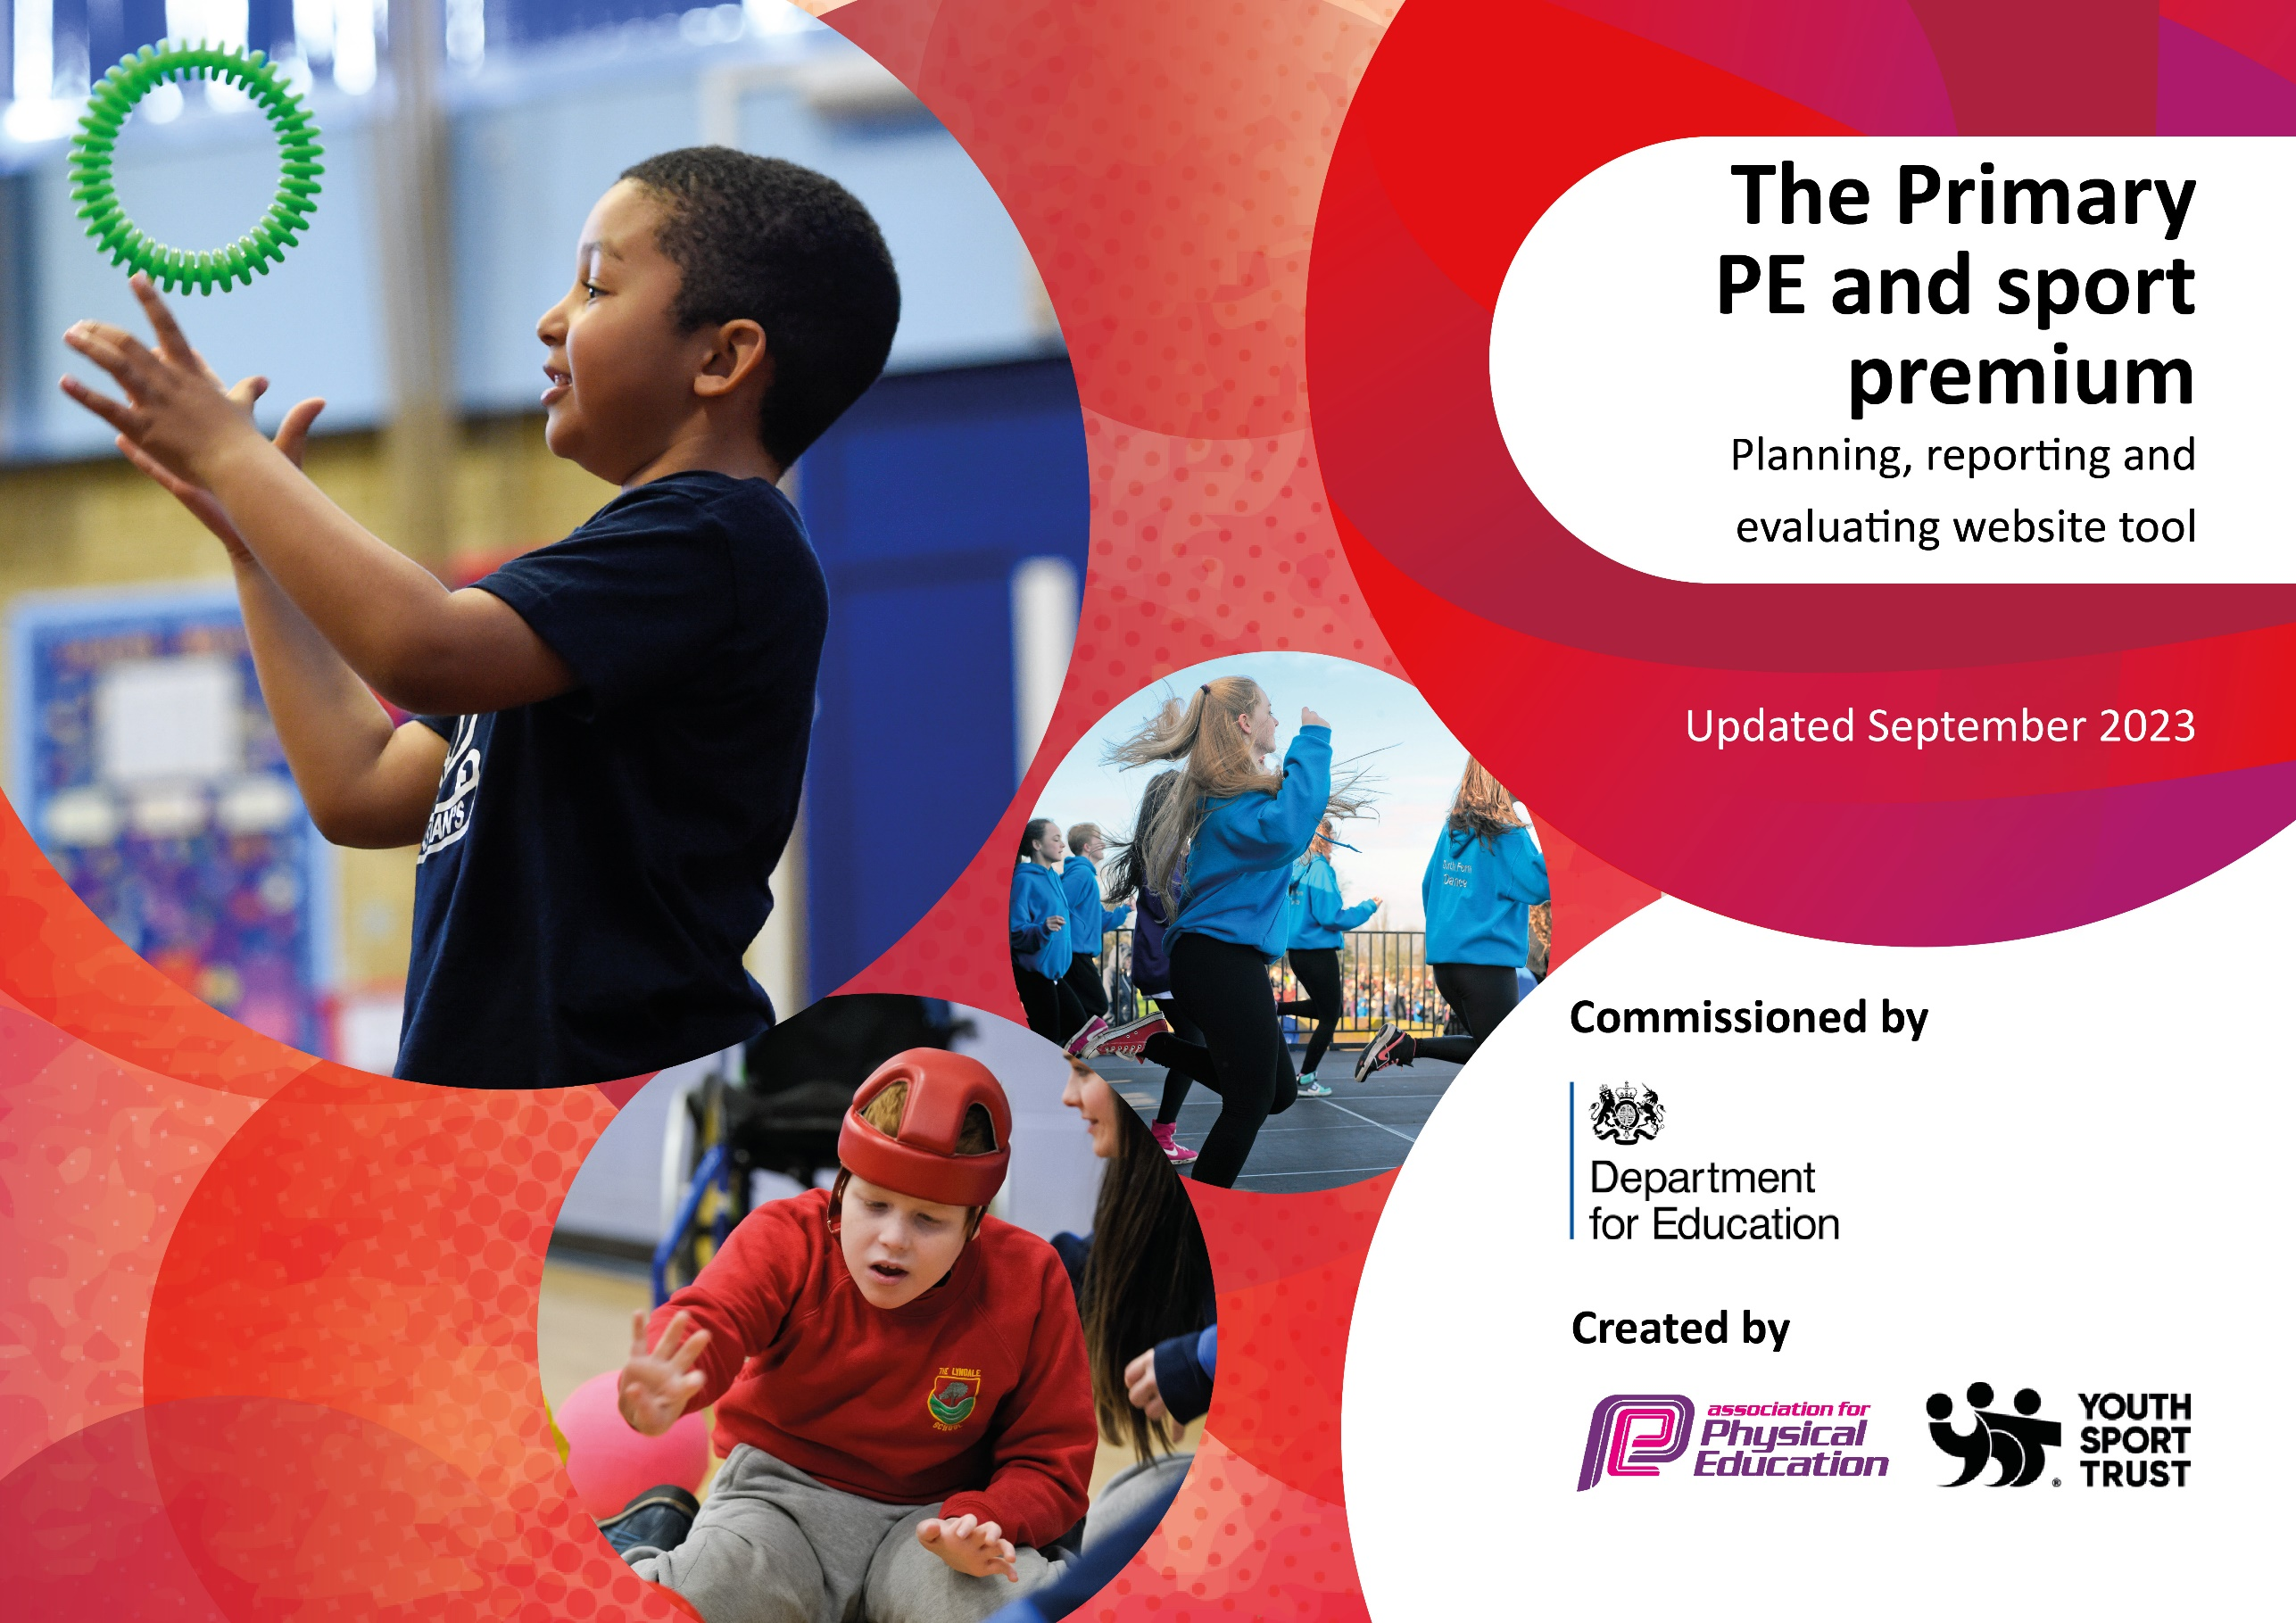

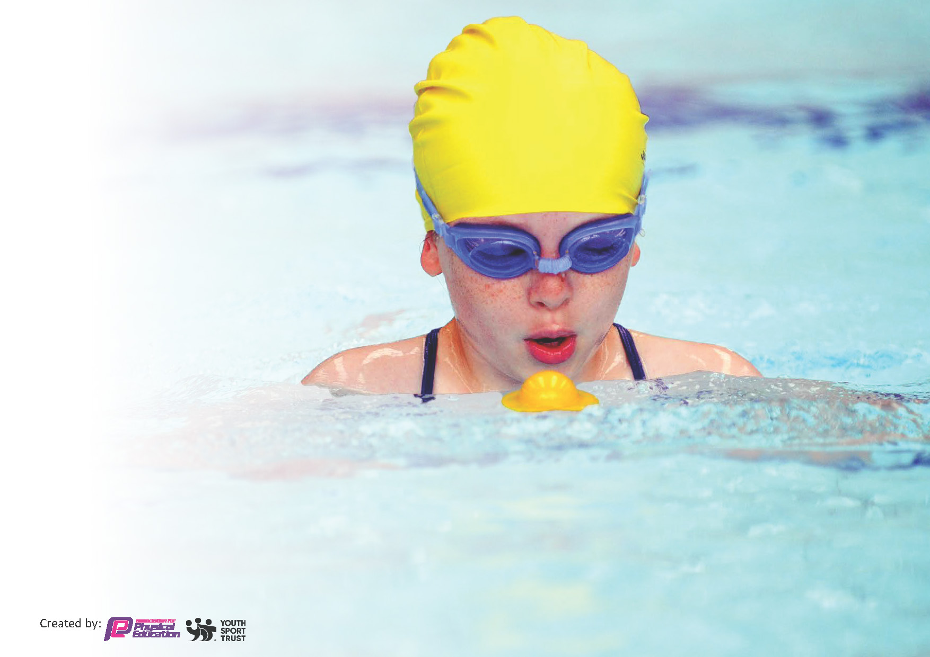
This template can be used for multiple purposes:
by:
- It enables schools to effectively plan their use of the Primary PE and sport premium
- It helps schools to meet the requirements (as set out in guidance) to publish information on their Primary PE and sport premium
- It will be an effective document to support Ofsted inspections enabling schools to evidence progress in Physical Education (PE) and evidence swimming attainment, which forms part of the PE National Curriculum. We would recommend schools consider
the Intent, Implementation and Impact of any spend, as examined within the Education Inspection Framework.

It is important that your grant is used effectively and based on school need.

Schools must use the funding to make additional and sustainable
improvements to the quality of the PE, School Sport and Physical Activity (PESSPA)
they offer. This means that you should use the Primary PE and sport premium to:

- Build capacity and capability within the school to ensure that improvements made now will benefit pupils joining the school in future years
- Develop or add to the PESSPA activities that your school already offers.

The Primary PE and sport premium should not be used to fund capital spend projects; the school’s core budget should fund these. Further detail on capital expenditure can be found in the updated Primary PE and sport premium guidance.

The Primary PE and sport premium guidance, outlines 5 key priorities that funding should be used towards. It is not

necessary that spending has to meet all the key priorities, you should select the priorities that you aim to use any funding towards.

Although completing this template is not a requirement for schools, schools are required to publish details of how they spend this funding. Schools must also outline what the impact this funding has had on pupils’ PE and sport participation and attainment and how any spending will be sustainable in the future. All funding must be spent by 31st July 2024.

The Department for Education has worked closely with the Association for Physical Education (afPE) and the Youth Sport Trust (YST) to develop this template and encourages schools to use it. This template is an effective way of meeting the reporting requirements of the Primary PE and sport premium.
Review of last year’s spend and key achievements (2023/2024)

We recommend you start by reflecting on the impact of current provision and reviewing your previous spend.

Activity/Action | Impact | Comments
Ensuring school curriculum and delivery is high quality and ensures all children across KS2 have regular daily physical activity  All children to take part in ‘1k-a-day’ to get ALL pupils undertaking at least 30 minutes of additional activity per day at school.  Pupils to experience high quality PE and Sport by ‘up skilling’ staff in PE subject specific knowledge  Provide extra-curricular clubs and inter school competition events for every year group throughout year  House assembly and competitions linking to PE, celebrating achievements.  Specialist PE teacher/coach providing children with a variety of sports and activities at a high standard  Extra curricular programme is broad and offers variety to each year group throughout school year  Half termly House/PE competitions  School Sports day  SPIN events | Timetables will be set and monitor provides evidence that physical activity is being completed daily by all children  Baselines of basic skills completed starting at Y3 to ensure teaching to meet needs of pupils and progression from right starting points  Children will feedback positively about their physical activity programme  All children can take part in PE with PE kit  SIMs and CPOMs behaviour analysis show a reduction in disruption in lessons from identified vulnerable groups ( SEN (SEMH) boys)  2 termly House PE events completed  QA monitoring evidence of standards of learning and teaching  CLICK milestone analysis shows increase in % of children achieving NC statements in PE  2 PE planned CPD events - teacher feedback and evaluation is positive and constructive  Displays celebrate PE across school and evidence skills and knowledge developed by children  House Captains/SSOC (School Sports Organising Crew) to assist MT with planning and running of events  Staff CPD, visit events or extra curricular clubs for pupils will be attended  PE curriculum grid and QA evidence of sports being taught  Planning incudes broad spectrum of sports and allows for progression of skills  Pupil voice and teacher feedback is positive and constructive towards next steps  Wide variety of PE lessons/clubs inc ‘different’ sports (Jui Jitsu, Fencing, handball, Boccia etc)  School maintained School Games GOLD overall  Several successes in cross country and school athletics- pupil asked to represent Yorkshire | Identify vulnerable/target group as case study of impact – develop focussed PE activity groups to address child obesity/inaction/reluctant girls  1k-a-day firmly embedded in school day.  CPD calendar planning with SB/MT  Identify NC statements and analysis tool to use for subject progression documents  Ensure teacher feedback taken from CPD events - leads into next planned CPD session  Pupil voice and celebration of developments - good practice? What are other schools doing?  MT/SB/LC to hold half termly meetings with House Captains  Evaluate sports/activities taught over last 2 years - what would a child experience in their journey through PE and Sport at our school?  Map CPD and skills training against the broad spectrum of sports - identify skill strengths in staff  MT/SB to continue to monitor upcoming events and to enter a variety of competitions to ensure all year groups etc are included – calendar of year planned in advance including transport and risk assessments to ensure

Key priorities and Planning
This planning template will allow schools to accurately plan their spending. £18750 24/25 income

Action – what are you planning to do | Who does this action impact? | Key indicator to meet | Impacts and how sustainability will be achieved? | Cost linked to the action
We plan to continue engaging with SPIN to enhance physical education and well-being programs for our students. This includes utilizing SPIN's support for staff training, accessing free competitions, ensuring safety, and leveraging their expertise in curriculum planning to improve overall school performance.  We plan to employ Laura, a specialist PE coach, to provide additional support beyond the SPIN program. She will co-deliver PE lessons with teachers, where teachers will teach every other lesson, and Laura will help support them in delivering high-quality instruction. Additionally, Laura will prepare student sports leaders to organize and participate in school events and competitions.  Provide rewards and incentives for sporting events, 1K a day and SPIN events including PE start of the week  Provide Travel and access to events  Enhance and provide equipment in school | This action impacts students in Years 3 to 6, teaching staff, and the broader school community. Students benefit from improved physical education experiences, while staff gain professional development and support. It also indirectly impacts parents, as their children receive better opportunities to engage in physical activity and sports.  This action impacts students in Years 3 to 6 by enhancing the quality of their physical education and providing leadership roles through sports leader training. It will also support teachers by boosting their confidence and competence in teaching PE. Sports leaders will gain valuable organizational and leadership experience, benefiting the whole school community during events.  Providing rewards and incentives for children to participate in sports and physical education (PE) in school can be a powerful motivator, encouraging greater engagement and fostering a positive attitude towards physical activity. Rewards, whether in the form of recognition, certificates, or small prizes, can boost children's self-esteem and give them a sense of accomplishment, reinforcing their commitment to staying active. These incentives help create a culture of celebration around physical achievements, making sports and PE more appealing, especially to those who may not naturally gravitate towards it. Furthermore, incorporating rewards helps children set goals, develop perseverance, and build a sense of teamwork, all of which contribute to their overall personal and social development. This approach not only enhances participation but also promotes a lifelong appreciation for health and fitness.  Providing transport for children to sporting events can have a significant positive impact on both the children and the broader community. It increases accessibility, especially for families who may face financial or logistical barriers, ensuring that all children, regardless of their circumstances, have the opportunity to participate. Regular participation in sports promotes physical health, fosters teamwork, and builds social skills, which are essential for personal development. Moreover, organized transport can improve safety by reducing the need for families to arrange individual rides, potentially lowering traffic and parking congestion at events. This support also alleviates stress on parents, allowing them to better balance their work or other responsibilities, knowing their children can attend these enriching activities  Providing a variety of equipment for sports and physical education (PE) in schools is crucial for fostering an inclusive and engaging environment for all students. A diverse range of equipment ensures that children with different interests, abilities, and fitness levels can participate in activities that suit their needs, helping to build confidence and enthusiasm for physical activity. It encourages creativity, allowing students to explore different sports, from traditional team games to individual or non-competitive activities, broadening their experience and promoting lifelong fitness habits. Access to a variety of equipment also helps develop different motor skills and improves physical literacy, enhancing both the educational and physical development of children. By catering to diverse preferences, schools can keep students motivated, ensuring higher participation rates and promoting an active, healthy lifestyle. | We aim to meet Key Indicator 1 (The engagement of all pupils in regular physical activity) and Key Indicator 3 (Increased confidence, knowledge, and skills of all staff in teaching PE and sport) from the PE and Sport Premium. By working with SPIN, we will ensure that all students engage in physical activity regularly, while our staff are equipped with the knowledge and skills to deliver high-quality PE lessons  This initiative will address Key Indicator 2 (The profile of PE and sport being raised across the school as a tool for whole-school improvement), Key Indicator 4 (Broader experience of a range of sports and activities offered to all pupils) and Key Indicator 5 (Increased participation in competitive sport). By having Laura involved, students will be exposed to a wider variety of sports and activities, while the sports leaders will help organize and encourage participation in competitive events within and beyond the school.  This initiative will address Key Indicator 2 (The profile of PE and sport being raised across the school as a tool for whole-school improvement), Key Indicator 4 (Broader experience of a range of sports and activities offered to all pupils) and Key Indicator 5 (Increased participation in competitive sport).  We aim to meet Key Indicator 1 (The engagement of all pupils in regular physical activity)  This will address Key Indicator 2 (The profile of PE and sport being raised across the school as a tool for whole-school improvement), Key Indicator 4 (Broader experience of a range of sports and activities offered to all pupils) and | The impact will be increased student participation in physical activity, improved physical fitness, and stronger staff skills in delivering PE lessons. Sustainability will be achieved through continuous professional development (CPD) for staff, fostering a culture of active learning, and maintaining access to SPIN’s resources, ensuring long-term integration of physical activity into our school’s daily routines.  The impact will be seen in students' broader engagement with new sports, increased participation in competitive events, and enhanced teacher capabilities in PE delivery. Sustainability will be achieved by developing teachers’ confidence and skills through their collaboration with Laura, ensuring they can independently lead high-quality PE in the future. Sports leaders will establish a long-lasting culture of student-led events and competitions, promoting ongoing engagement in physical activity throughout the school.  The impact of providing rewards and incentives for children’s involvement in sports and PE in school is far-reaching, both in the short and long term. In the short term, such programs can lead to higher levels of participation, enthusiasm, and engagement among students. They help children develop a positive relationship with physical activity, which improves physical health, mental well-being, and social skills like teamwork and discipline. In the long term, regular participation in physical activities nurtures healthy habits that can last a lifetime, reducing the risk of chronic diseases and promoting a balanced lifestyle.  To achieve sustainability, schools must focus on creating a culture of inclusion, where rewards and incentives are part of a broader, ongoing effort to value physical activity, not just as a competition, but as a vital part of personal development. This can be done by providing a variety of physical activities that cater to different interests, ensuring that all children feel encouraged to participate. Schools should also work to build partnerships with local sports clubs and community organizations to support ongoing opportunities for engagement outside of school. Sustainable programs also involve educating students on the intrinsic benefits of physical activity, such as health, well-being, and social connection, which helps foster long-term motivation beyond external rewards.  The impact of providing a variety of equipment for sports and PE is substantial in terms of both student engagement and overall physical development. Access to a wide range of equipment fosters inclusivity, as it allows students of all skill levels and interests to find activities they enjoy, increasing participation rates. This variety helps students develop diverse physical skills—strength, coordination, balance, and agility—while also promoting social skills such as teamwork, cooperation, and problem-solving. Additionally, exposure to different sports and activities at an early age can help children discover new interests, laying the foundation for a lifelong commitment to fitness and health.  To achieve sustainability, schools must maintain and replenish equipment regularly while prioritizing durable, multi-functional tools that can be used across different sports and activities.. Encouraging proper care and responsibility for the equipment through student involvement also extends its lifespan. Finally, schools should focus on integrating diverse equipment into a well-rounded PE curriculum that emphasizes the importance of physical activity, thus creating a lasting culture of fitness and well-being among students. | 3764  6075 + 1500 for additional events  2000  2000  4000

Key achievements 2023-2024
This template will be completed at the end of the academic year and will showcase the key achievements schools have made with their Primary PE and sport premium spending.

Activity/Action | Impact | Comments
Child reaching national cross country final in Loughborough | One of our students reached the national cross country final, representing the school at a prestigious level. This achievement has raised the profile of running and competitive sport across the school, inspiring peers and boosting school pride. | This success highlights the talent within our school and demonstrates the value of nurturing individual athletic potential.
Solidly implemented 1k a day into the school d | The "1k a Day" initiative has been fully embedded into the daily routine, improving overall student fitness, concentration, and mental well-being. This consistent activity has contributed to better physical health and more energized students throughout the day. | The initiative has been embraced by both staff and students, promoting a culture of regular physical activity that is sustainable for the long term.
Team reaching regional cross country finals | Our cross country team’s achievement in reaching the regional finals has fostered a sense of teamwork, resilience, and commitment. It encourages more students to participate in athletics and raises aspirations for competitive sports. | This success reflects the growing strength of our athletics program and the dedication of both students and staff to improve performance.
Team reaching Yorkshire Sports Hall Athletic Finals | The team’s success in reaching the Yorkshire Sports Hall Athletic Finals has showcased our school's versatility in athletics, with students excelling in various disciplines. It has increased participation in track and field activities. | This achievement demonstrates the depth of talent in our school, motivating students to try new events and work hard in their training.
Attending multiple SEND events | By attending multiple SEND sports events, we have provided inclusive opportunities for all our students, ensuring everyone can participate and benefit from physical activity. This has improved confidence and social inclusion for SEND pupils. | These events have been pivotal in promoting inclusivity and encouraging participation in sports among students with special educational needs.
Receiving Gold School Games Mark for a second year in a row | Earning the Gold School Games Mark for a second consecutive year reflects our commitment to high-quality PE and sport. It recognizes our wide participation and competitive success across the school, boosting the reputation of our sports program. | This award is a testament to the hard work of both staff and students in promoting physical education and maintaining a high standard of school sport.
Successfully running a girls' football day event to increase awareness | The girls' football day event was highly successful, increasing awareness and participation in girls’ football. It empowered female students to engage more in football and promoted gender equality in school sports. | This initiative has laid the groundwork for sustained involvement of girls in football, helping to challenge stereotypes and foster an inclusive environment.
Hugely successful sports day with 100% positive feedback | Our sports day received 100% positive feedback from staff, students, and parents, celebrating a day of fun, competition, and community spirit. It provided a platform for all students to participate and showcase their athletic abilities. | The overwhelming positive feedback highlights the success of the event, and it continues to be a key moment in fostering school-wide engagement in sports.
Wider range of pupils accessing sports events | More students than ever before are participating in sports events, with increased access across different year groups and abilities. This has led to greater enthusiasm for sport, improved physical fitness, and stronger school engagement. | By offering a diverse range of sports opportunities, we are ensuring that students of all interests and abilities feel included in the school’s sports culture.

Swimming Data
Meeting National Curriculum requirements for swimming and water safety.
Priority should always be given to ensuring that pupils can perform safe self-rescue even if they do not fully meet the first two requirements of the National Curriculum programme of study

Question | Stats: | Further context  Relative to local challenges
What percentage of your current Year 6 cohort can swim competently, confidently and proficiently over a distance of at least 25 metres? | % | Use this text box to give further context behind the percentage.  e.g., 30% - we are struggling to get pool space due to our local pool closing so we have had to use a much smaller local school pool. We have had to limit the number of pupils attending swimming lessons during one term which means some pupils have attended fewer swimming lessons than others.
What percentage of your current Year 6 cohort can use a range of strokes effectively [for example, front crawl, backstroke, and breaststroke]? | % | Use this text box to give further context behind the percentage.  e.g., Even though your pupils may swim in another year please report on their attainment on leaving primary school at the end of the summer term 2024

What percentage of your current Year 6 cohort are able to perform safe self-rescue in different water-based situations? | % | Use this text box to give further context behind the percentage.
If your schools swimming data is below national expectation, you can choose to use the Primary PE and sport premium to provide additional top-up sessions for those pupils that did not meet National Curriculum  requirements after the completion of core lessons. Have you done this? | Yes/No
Have you provided CPD to improve the knowledge and confidence of staff to be able to teach swimming and water safety? | Yes/No

Signed off by:

Head Teacher: | Zoe Lowe
Subject Leader or the individual responsible for the Primary PE and sport premium: | Matthew Tate/ Saoirse Brian
Governor: | Geoff Kernan
Date: | 01.10.2024

